**Title page**

**UNIVERSITY: JOMO KENYATTA UNIVERSITY OF AGRICULTURE AND TECHNOLOGY**

**COURSE: BSc. COMPUTER SCIENCE**

**UNIT CODE: ICS 2209**

**UNIT NAME: DESIGN AND IMPLEMENTATION OF COMPUTER APPLICATIONS**

**GROUP MEMBERS:**

1. **SERENA MUMBI- SCT 211-0581/2021**
2. **GEOFFREY CHEGE- SCT 211-0002/2019**
3. **AKECH DAU-SCT 211-535/2022**
4. **JOHN KABUTHI-SCT 211-0055/2022**
5. **DERRICK GACHERU-SCT 211-0004/2021**
6. **DALVIN CALVIN-SCT 211-0452/2022**

**Title: Inventory Management system**

**Brief Description**

The proposed Inventory management system aims to streamline inventory tracking and management processes for businesses, providing real-time insights into stock levels, sales trends, and procurement needs. It will automate inventory-related tasks, reducing manual efforts and errors while improving operational efficiency.

**What the software will do:**

The software will provide the following functionalities:

1. Inventory Tracking: Monitor stock levels, item locations, and movement within the inventory.
2. Order management: Manage purchase orders, sales orders, and returns efficiently.
3. Reporting: Generate reports on the inventory turnover, sales performance and stock valuation.
4. Supplier Management: Maintain supplier information, track deliveries, and manage vendor relationships.
5. User access control: Implement role-based access control to restrict access to sensitive inventory data.

**Potential clients/users:**

1. Retail businesses: Online retailers are looking to manage their inventory effectively.
2. Distributors: Entities involved in the distribution of products across various channels.
3. Manufacturers: Companies producing goods and managing raw material inventories.
4. Wholesalers: Businesses involved in bulk sales of goods to retailers or other businesses.

**Functional Requirements**

1. Inventory Tracking: The system should allow users to track items by barcodes or serial numbers.
2. Reporting: Generate various reports, such as inventory status, sales trends and stock valuation.
3. Order management: Enable users to create, modify and fulfill purchase and sales orders.
4. User access control: Implement authentication and authorization mechanisms to control user access to system features.
5. Supplier management: Provide functionalities for adding, editing and managing supplier information.

**Non-Functional Requirements**

* Performance: Ensure the system can handle high volumes of transactions and users without significant performance degradation.
* Scalability: Develop the system to scale seamlessly as the business grows, accommodating increased data and user loads.
* Reliability: Design the system to the robust and reliable, minimizing the risk of data loss or system downtime.
* Security: Implement security measure to protect sensitive inventory data from unauthorized access or manipulation.
* Usability: Create an intuitive user interface with clear navigation and user-friendly features.

**Software and Hardware Requirements.**

**Software:**

1. Programming language: Visual Basic
2. Framework: VB.NET and ASP.NET
3. Database management system: SQL Server or Microsoft Access
4. Frontend Technologies:(ASP.NET Controls and also HTML, CSS, JavaScrip )
5. Version Control: Git, Visual Basic

**Hardware:**

1. Server: Intel Xeon Processor, 32GB RAM, 1TB SSD
2. Client Devices: Desktops, laptops, tablets and smartphones with modern web browsers

**Database Designs**

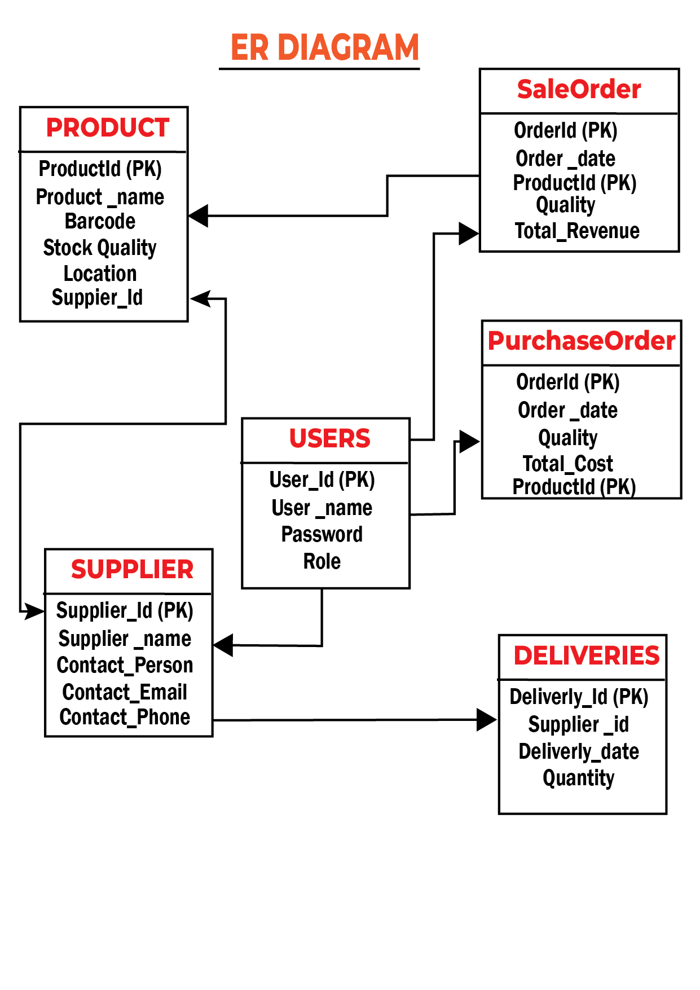

**NB: ER DIAGRAMS ARE SUSCETIPLE TO CHANGES DURING THE DEVELOPMENT PHASE**

**User Interface (UI) and User Experience (UX)Designs**

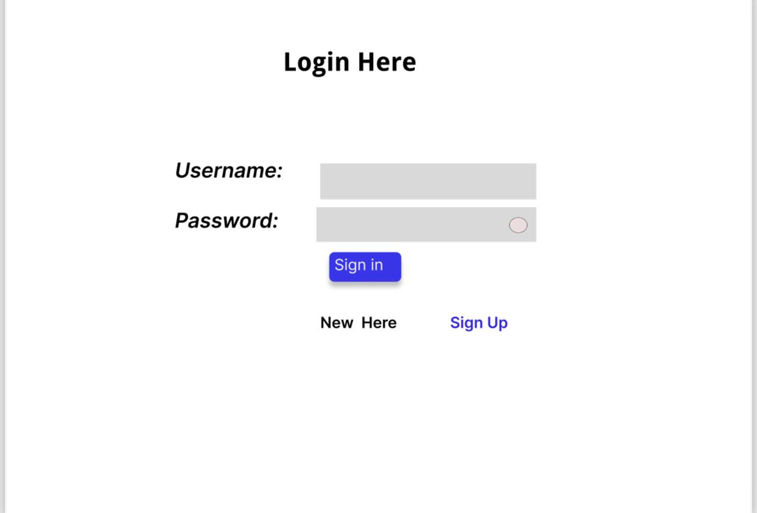

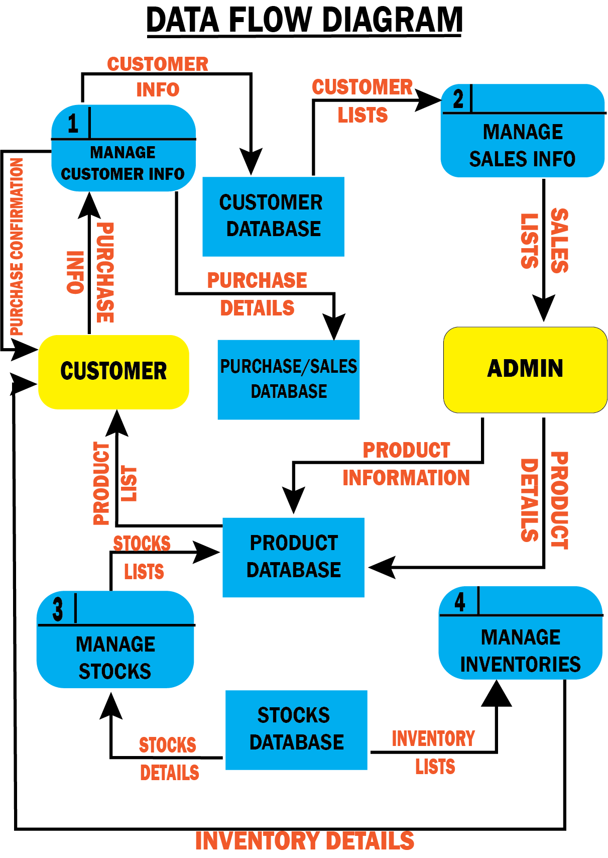

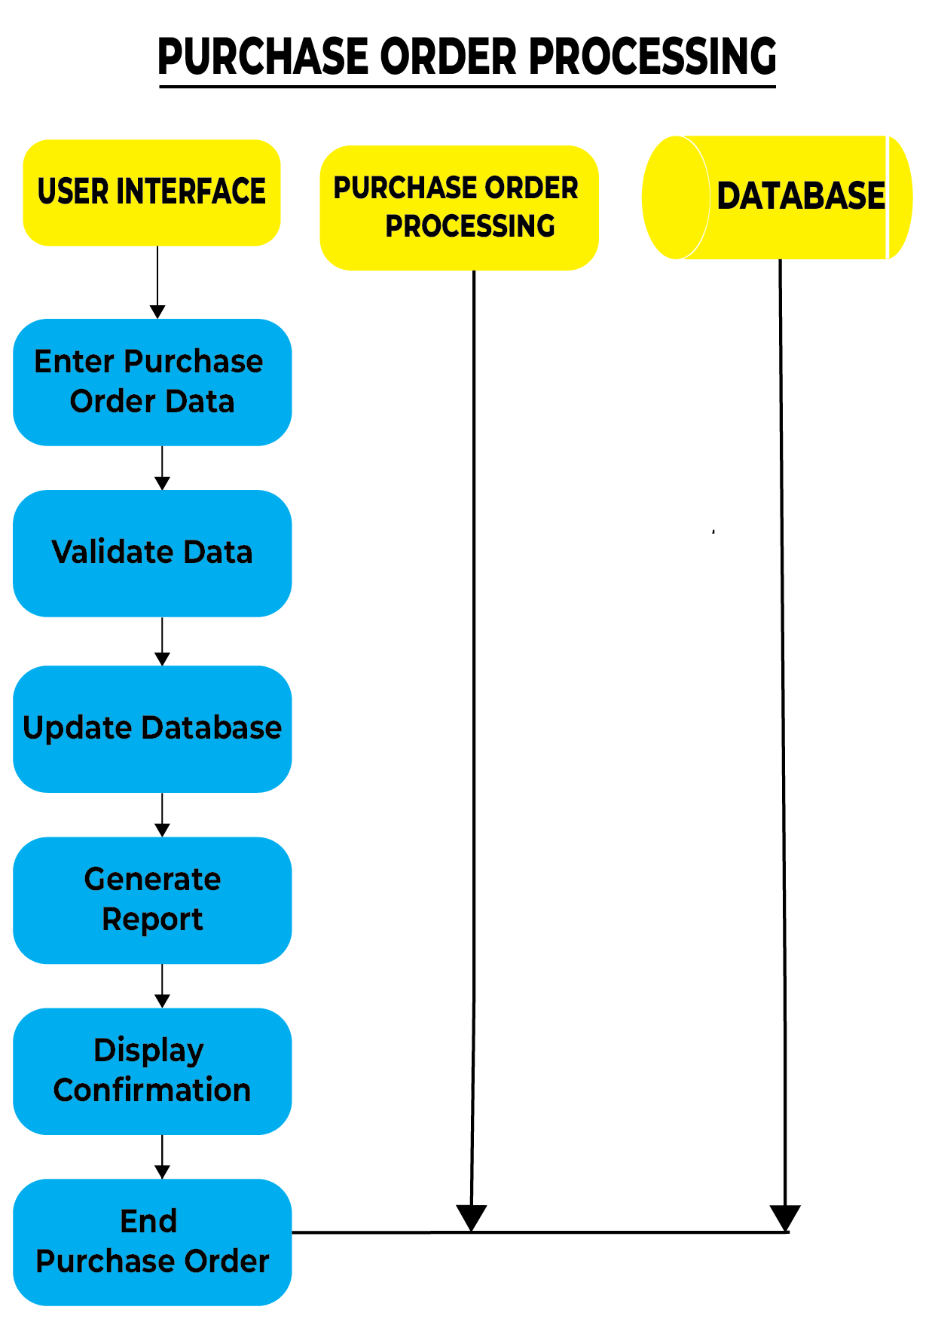

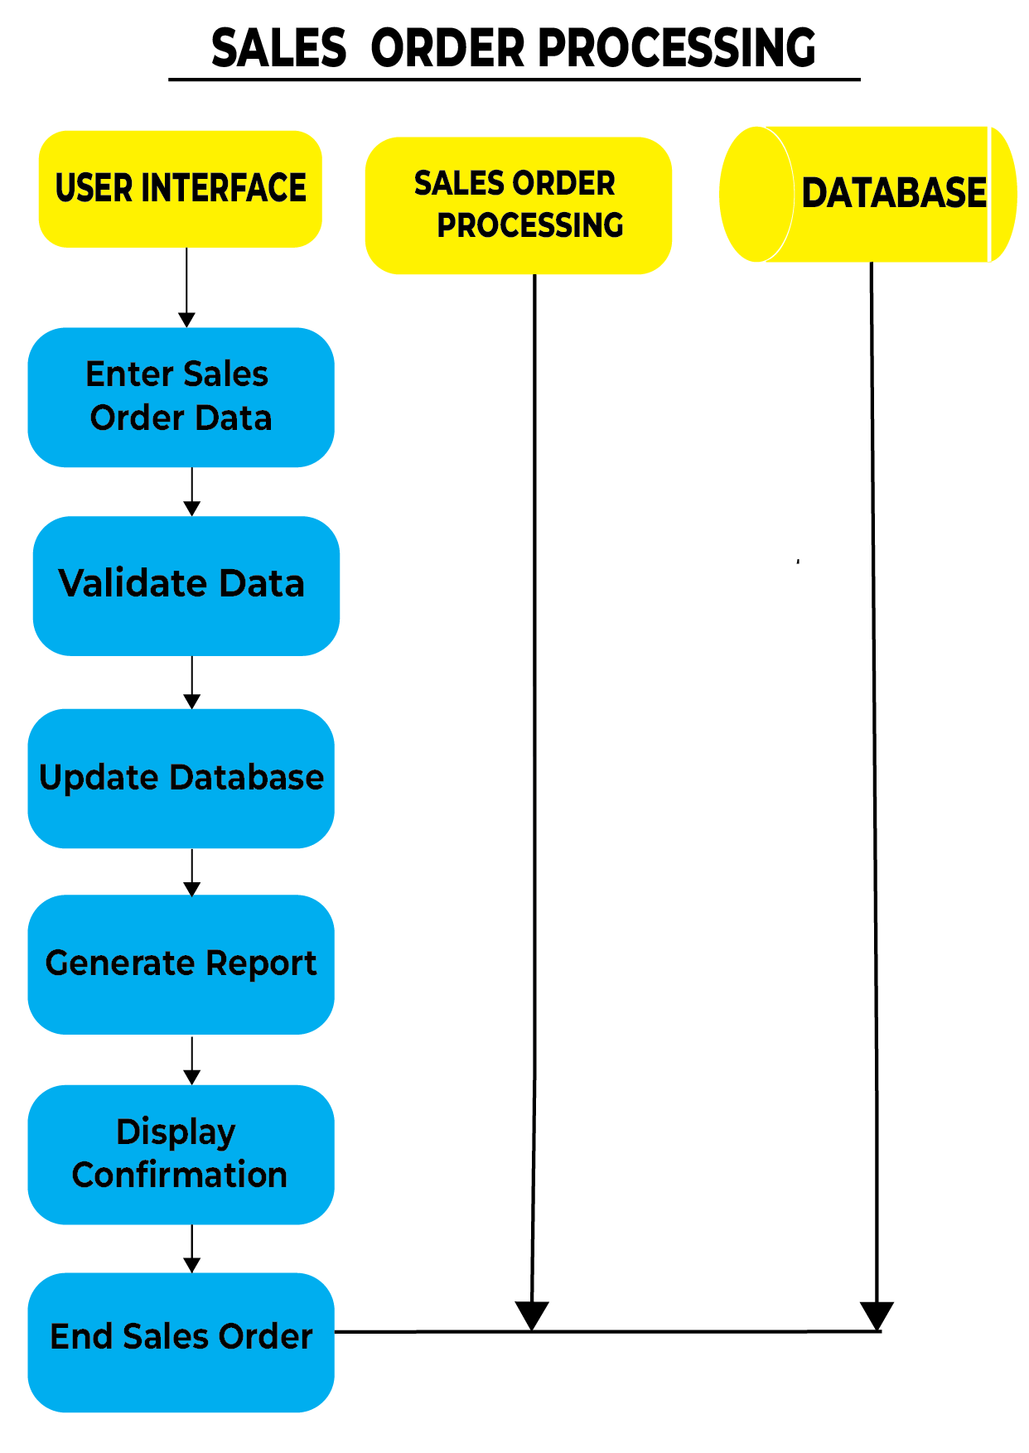

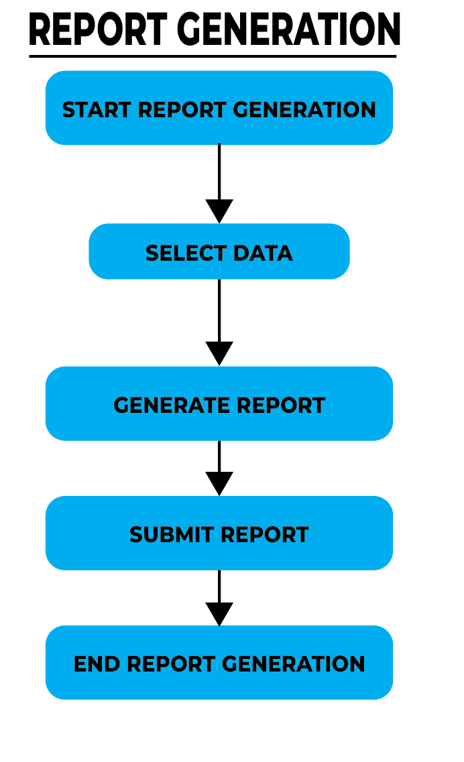

**Schedules**

|  |  |  |
| --- | --- | --- |
| **Activity** | **Weeks** | **What is to be done** |
| Feasibility Study | 1 | Identified project scope, objectives, and feasibility assessment |
| Design | 2-3 | Interface, database, and program design; flowcharts and diagrams |
| Programming | 4-5 | Implementation of source code and database functionality |
| Testing | 6 | Test reports, debugging and ensuring system reliability |
| Presentations | 7 | Final software and system documentation, project presentation |

**This proposal outlines the development of an inventory management system, detailing its functionalities, requirements, and project schedule. It aims to address the needs of businesses in efficiently managing their inventory operations.**